Andrea Kilov- Speech Pathologist and Audiologist
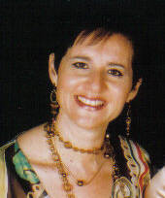

Name Andrea Kilov
Qualification/s BA (Sp &H Th) Hons

Suburb Como
Phone 08 9313-2113
Mobile 0411 754746
Fax 08 9313-3063
Email kilov @arach.net.au
Registered for Private Health funds: yes
HIC Registered: Yes

Age of Clients Seen: 3-15 years
Areas of special interest: School aged language/literacy; Auditory Processing

Referrals accepted for clients with the following communication disorders:
Articulation, Phonology, Phonological Awareness, school age language/learning disability. Auditory processing

Andrea Kilov graduated as a Speech Pathologist and Audiologist in 1983. Since that time she has worked as both a Speech Pathologist and Audiologist in a variety of setting in both South Africa and Australia. Andrea has presented workshops and seminars to parents, teachers and allied health professionals on early literacy development, speech, language and phonological development as well as school aged literacy and Spelling. She has worked on the Ear Health team as an Audiologist and is currently an approved Trainer for the Smart Words –Word Study Program. Andrea has a special interest in literacy development including phonological awareness and spelling. Andrea is a certified practising speech pathologist.

