Practice Name: Speech Therapy Services
Name: Denise Bain
Qualification/s: BA (1981), Dip Ed. (1982),
BSc.(Human Communication Science, 2001)

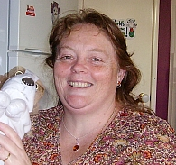
Passport Photo

Suburb: Canningvale
Phone: (08) 9455 3927
Mobile: 0414943708
Fax: (08)9456 4636
Email: aldenbain@bigond.com
Registered for Private Health funds: Yes
HIC Registered: Yes
Age of Clients Seen:
0-6 years
Adults
Areas of special interest:
Toddlers
Autistic spectrum disorders.
Adult dysphagia

Referrals accepted for clients with the following communication disorders:
Paediatrics: 0-6 years
Disabilities
Autism
Adults: Language
Swallowing Disorders

Denise graduated with distinction from Curtin university in 2001.
She has worked with a variety of clinical populations since graduation, commencing private practice in 2006. She has experience in managing a varied caseload with current clients ranging from :children 0-6, disabilities, autism, and adults in acute and residential settings.

