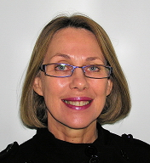

Jennifer Lynne Britten

Name: Jennifer Britten
Qualification/s: MSc (London) LACST

Suburb: Attadale
Phone: (08) 9330 4976
Mobile: n/a
Fax: (08) 9317 1807
Email: britstan@iinet.net.au
Registered for Private Health funds: yes
HIC Registered: yes

Age of Clients Seen: 0-16 years

Areas of special interest: children/adolescents and their families

Referrals accepted for clients with the following communication disorders: delayed language acquisition, specific language impairment (SLI), speech/language disorders, dyslexia, auditory processing disorders, literacy problems and autistic spectrum disorders

About Jennifer

Jennifer graduated in 1970, working in rural Victoria and Melbourne before doing an MSc at London University. She then became the Supervising Speech Pathologist in Community and Child Health Services and the Rheola St Child Development Centre in Perth WA. She presented widely to forums and conferences for community health nurses, paediatricians and colleagues, as well as participating in the development of support resources.

Jennifer, who has been in Private Practice for 18 years and uses a family-centred approach, is a Certified Practising Speech Pathologist.

