Liana Gunzburg Speech Pathologist
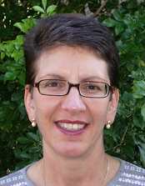

Name: Liana Gunzburg
Qualification/s: B.App.Sc (S & H), MSPA, CPSP

Suburb: Dianella
Phone: 9275 5359
Mobile: NFP
Fax: 9375 8336
Email: liana@iinet.net.au
Registered for Private Health funds: yes
HIC Registered: Yes

Age of Clients Seen: 2-18

Areas of special interest: Literacy difficulties

Referrals accepted for clients with the following communication disorders:Articulation, phonology, dyspraxia, early language, school-age language, literacy, learning difficulty, adolescent language.

About Liana:

Following graduation in 1982 Liana worked in a range of hospital and community health settings, both country and metropolitan before turning to private practice in 1995. Since that time Liana has developed a particular interest and expertise in school-age language and literacy difficulties. This was fostered by working at Scotch College Junior School for 7 years (alongside private practice), assisting boys with language and literacy learning difficulties. However, she continues to maintain skills and interest in early language and phonology.

Liana is an active member and the inaugural Life Member of the PSPAWA.

