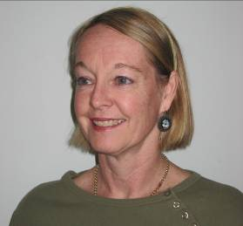
Region: Metropolitan
Name: Penelope Cromack

Address: 44 Doonan Rd, Nedlands, , Wanneroo Professional Centre, 771 Wanneroo Rd, Wanneroo 9389 8390
Age of Clients Seen: Birth - Teenagers
Special Areas of Interest: Early Language,
Phonological Disorders, Literacy Difficulties, Stuttering, Auditory Processing Difficulties, Intellectual Disability
Registered with Medicare: Yes
Registered with Private Health Insurance Providers: Yes
Referrals accepted for clients with the following communication disorders: Language Delay, Unintelligible Speech, Dyspraxia, Stuttering, Literacy problems, Auditory Processing difficulties, Intellectual disability.
Penelope Cromack qualified in Speech Pathology in 1979 and is a Certified Practising Speech Pathologist. She commenced working at Pinjarra Hospital and was instrumental in establishing the first public Speech Pathology clinic in Mandurah. She then worked for 8 years at Princess Margaret Hospital treating a wide variety of speech and language disorders and serving on head injury, cleft palate and fluency teams. After this she worked with intellectually disabled children at AIH for 2 years. In 1993 she established her own private practice in West Leederville and Joondalup. Currently these practices are located in Nedlands and Wanneroo.

